Design Plan
  - Portfolio task 3
Unit code: COS40005 EAT40005
Unit Name: Computing Technology/ Engineering project A
Submission date:

[This is a template, remove any text within third brackets before submission]

Student Name | Student Id | Statement of contribution to the report
Prabesh Bhattarai | 104085535 | System Architecture and System Design Research
Nur E Siam | 103842784

Acknowledgment of Country ( Anyone)
We respectfully acknowledge the Wurundjeri People of the Kulin Nation, who are the Traditional Owners of the land on which Swinburne’s Australian campus is in Melbourne’s east and outer-east, and pay our respect to their Elders past, present and emerging.
We are honoured to recognise our connection to Wurundjeri Country, history, culture, and spirituality through these locations, and strive to ensure that we operate in a manner that respects and honours the Elders and Ancestors of these lands.
We also respectfully acknowledge Swinburne’s Aboriginal and Torres Strait Islander staff, students, alumni, partners and visitors.
We also acknowledge and respect the Traditional Owners of lands across Australia, their Elders, Ancestors, cultures and heritage, and recognise the continuing sovereignties of all Aboriginal and Torres Strait Islander Nations. Each team member identifies the Traditional Owners of the land they lived on while completing this work (if living in Australia).

problem Overview (Ruffin)
[Add a high-level summary of the problem that needs to be solved in the project. Identify the aim, purpose and objectives of the project. This is a one paragraph compilation of previous requirement document.]
The real estate market in Bangladesh faces inefficiencies due to the lack of a centralized platform with features like real-time updates, interactive maps, and user verification. To address this, this project is committed to developing a mobile and web platform using Amazon AWS for scalable cloud hosting, ReactJS for the web frontend, MySQL for managing property listings and user data, and Kotlin for Android mobile development. The team brings experience in handling projects with ReactJS, MySQL, and AWS, and has conducted research on the advantages of these technologies, particularly their scalability, security, and cost-effectiveness. AWS ensures reliable cloud infrastructure, ReactJS allows for dynamic and responsive user interfaces, and MySQL offers robust data management. The platform's goal is to enhance property transactions by integrating real-time map-based search and secure user verification, addressing the limitations of current platforms like Tolet and BD Housing.

Solution approach (Siam)

[Describe the chosen high-level architecture of the system that will be developed. Also discuss additional architecture alternatives that have been explored but not chosen. Note that this section is about the high-level architecture design, the lower-level details are expected in the following sub sections]
The solution architecture for the real estate platform is strategically designed using Amazon Web Services (AWS) to ensure scalability, security, and high performance for both mobile and web applications. The architecture enables seamless interaction between users and real estate professionals while maintaining data integrity and system reliability. Below is an overview of the high-level architecture, the components selected, and a brief discussion of alternatives that were considered but not chosen.
High-Level Architecture Design
The architecture is divided into distinct layers to ensure modularity, maintainability, and scalability:
1.User Interface Layer:
- Mobile Application (Android): The mobile app will be built for Android users, offering them functionality to browse property listings, communicate with professionals, and manage their profiles. The app will communicate with the backend via secure API endpoints exposed through AWS API Gateway.
- Web Application: The web app will offer a similar user experience to the mobile app, accessible via standard web browsers. Both applications will adhere to responsive design principles to ensure compatibility across different devices and screen sizes.
2.Backend Layer:
- AWS Lambda (Serverless Architecture): The core backend logic will be implemented using AWS Lambda, enabling a serverless approach that dynamically scales based on demand. Lambda will handle critical operations such as user authentication, managing property listings, handling API requests, and facilitating real-time communication between users.
- Amazon RDS (MySQL): A highly available, managed relational database will be used to store user profiles, property listings, transaction records, and other critical data. Amazon RDS provides built-in support for automatic backups, failover, and replication, ensuring data security and availability.
- Amazon S3: Media assets such as property images and other multimedia files will be securely stored in Amazon S3 buckets. This service offers highly scalable storage with lifecycle management policies to optimize storage costs. AWS Lambda functions will process and optimize images before they are uploaded to S3 for better performance and user experience.
- AWS API Gateway: API Gateway will serve as the entry point for all communication between the frontend applications (mobile and web) and the backend services, ensuring secure and scalable API interactions.
3.Security and Compliance Layer:
- Multi-Factor Authentication (MFA) and CAPTCHA will be implemented to enhance security during user authentication, preventing unauthorized access and ensuring data integrity.
- End-to-End Encryption: All communications between clients (mobile/web) and the server will be secured using HTTPS and TLS protocols, ensuring that sensitive data such as user credentials and property details are encrypted both in transit and at rest.
- AWS Identity and Access Management (IAM): Strict access controls will be enforced using IAM roles and security groups, ensuring that only authorized users and services can access sensitive resources.
4.Real-Time Interaction Layer:
- Google Maps API: Integrated for location-based property searches, the Google Maps API will allow users to view property listings on an interactive map, providing a more intuitive and efficient search experience.
- AWS SES (Simple Email Service): AWS SES will be used to send email notifications, alerts, and communication messages to users, such as notifications about new property listings or messages from real estate professionals.
- WebSockets: WebSockets will be used to facilitate real-time communication between users and real estate professionals, ensuring fast and efficient message delivery without requiring page reloads.
5.Scalability and Reliability Layer:
- Auto Scaling and Load Balancing: The architecture leverages AWS Auto Scaling to automatically adjust the number of EC2 instances in response to traffic demand, ensuring high availability and performance. An Elastic Load Balancer will distribute incoming traffic evenly across multiple instances, preventing any single point of failure.
- Amazon RDS Replication: RDS will utilize multi-AZ (Availability Zone) replication to ensure data redundancy and high availability. In case of a failure in one availability zone, the secondary instance in a different zone will take over, minimizing downtime.
- Amazon CloudFront: AWS CloudFront, a content delivery network (CDN), will be used to cache and deliver content globally with low latency. This will improve the performance of media-rich content such as property images and videos.
Architecture Alternatives Considered but Not Chosen:
- Monolithic Architecture: A monolithic architecture was initially considered due to its simplicity and ease of implementation. However, it was ultimately rejected due to the limitations it imposes on scalability, flexibility, and the ability to support future growth. In contrast, the chosen microservices and serverless architecture using AWS Lambda offers greater scalability and better resource utilization, enabling the platform to handle high traffic efficiently.
- On-Premises Infrastructure: Hosting the platform on an on-premises infrastructure was evaluated but discarded due to high upfront costs, maintenance overhead, and the lack of elastic scalability. AWS cloud infrastructure provides a more cost-effective solution, with the ability to scale resources dynamically based on demand, reducing both operational complexity and capital expenses.
- Third-Party Hosting Solutions: While third-party managed services such as DigitalOcean and Heroku were briefly considered, they were ultimately rejected due to limitations in control, scalability, and integration with advanced AWS services like RDS, S3, and CloudFront. AWS offers a comprehensive suite of services that integrates seamlessly, providing the necessary tools to support both current and future platform requirements.
The selected architecture harnesses the power of AWS cloud services, ensuring that the real estate platform is highly scalable, secure, and capable of handling large volumes of traffic and data. The modular design enables seamless integration of future features, such as enhanced verification processes and advanced analytics, while the serverless and auto-scaling infrastructure ensures cost efficiency. This robust architecture positions the platform to meet the evolving needs of the Bangladeshi real estate market and offers users a modern, efficient, and secure platform for property transactions.

System ARCHITECTURE (Prabesh)

[Present the system architecture in this section. Develop a high-level design (aka architecture diagram) of your project, indicating each component. Give a brief description of each component in your high-level design diagram and state their roles, responsibilities and justification. Include diagrams to illustrate the proposed architecture. Sub-sections can be added as appropriate.]
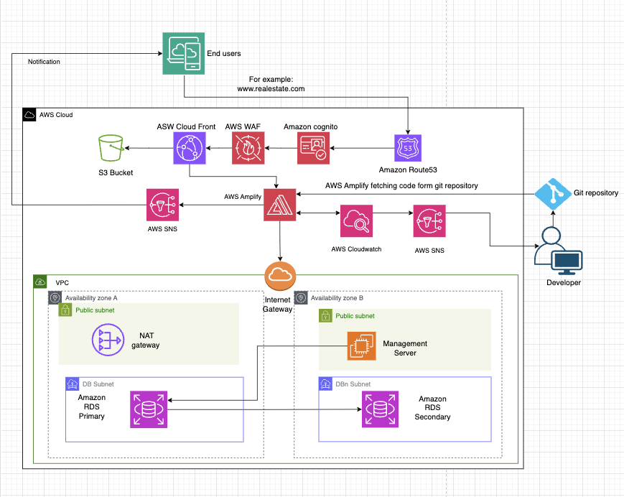
Fig. System architecture design using AWS compute services
The above presented diagram depicts the system architecture which will be hosting the Real Estate application using AWS cloud computer services. This architecture will be highly scalable, reliable, and cost-effective for small to medium size business, supports handling of traffic during peak hours without compromising performance or user experience. Moreover, other AWS services can be deployed to support the business growth with less administrative work. Below is a brief description of each AWS services with their roles, responsibilities and justification that will be used to host the application:
- Virtual Private Cloud (VPC)
- Role: VPC is a logically isolated section of the AWS cloud where several AWS resources can be launched in a virtual network.
- Responsibilities:
  - Controls network traffic using subnets, security groups, and Network Access Control Lists (NACLs).
  - Enables secure communication between instances within the VPC and the internet, or between instances and other AWS services.
- Justification: Ensures that the real estate website operates in a secure, isolated environment with full control over networking and security.

- Availability Zones
- Role: Physically separate datacenters within a region that provide redundancy and high availability.
- Responsibilities:
  - Distributes resources across multiple locations to minimize downtime and data loss during failures.
  - Ensures that traffic is spread across multiple instances in different Availability Zones for fault tolerance.
- Justification: Provides high availability and fault tolerance for the website, ensuring it remains operational even if one AZ experiences an issue.

- Private Subnets
- Role: Subnets that host resources not directly exposed to the internet such as database
- Responsibilities:
- Ensures that sensitive resources (e.g., databases) are not accessible from the internet, only from within the VPC or via controlled pathways (like the NAT Gateway).
- Justification: Enhances security by isolating backend components from direct public access, reducing attack surface and protecting sensitive data.

- Public Subnets
- Role: Subnets that host resources requiring direct internet access, such as the Application Load Balancer, NAT Gateway and test servers.
- Responsibilities:
- Hosts components that need to be accessible from the internet, while forwarding requests to backend services hosted in private subnets.
- Justification: Enables interaction between public-facing resources (like the ALB) and backend services, providing a secure and efficient network design.

- Amazon Route 53
- Role: Route 53 is a scalable Domain Name System (DNS) for routing end-users' requests to the web servers.
- Responsibilities:
- Routes traffic that is sent from the user to endpoints like EC2, S3, or AWS WAF
- Provides DNS health checks to ensure that traffic is directed only to healthy endpoints.
- Manages domains (can register, transfer, and configure DNS settings).

- Justification: Ensures reliable, low-latency DNS routing to direct users to your application’s web servers, contributing to the website’s availability

- AWS WAF (Web Application Firewall)
- Role: AWS WAF helps to protect the web application form common vulnerabilities like SQL injection, cross-site scription (XSS), and Distributed Denial of Service (DDoS) attack
- Responsibilities:
- Monitors HTTP/HTTPS requests and blocks malicious traffic.
- Provides granular control to the traffic.
- Customizable rule sets to filter traffic based on ip address, port number and limit the rate of traffic to avoid DDoS attack.
- Justification: Enhances the security of the real estate website by protecting it from common to large known attacks like DoS, DDoS, improving security compliance.
- Amazon Cognito
- Role: User authentication and identity management service.
- Responsibilities:
- Manages user registration, sign-in, and access control, supporting multi-factor authentication (MFA) and integration with social identity providers (like Google, Facebook).
- Supports millions of users with high performance.
- Justification: Helps scale the user base securely while providing a seamless login experience for both web and mobile users, ensuring that only authorized users can access secure features of the real estate platform.

- Amazon CloudFront
- Role: It is a high-speed and low latency content delivery service.
- Responsibilities:
- The main function of this service is to cache frequently accessed content at edge location for low-latency delivery.
- Distributes both static and dynamic content while protecting it with integrated security features like SSL and AWS Shield
- Justification: Reduces load on backend servers by serving cached content from edge locations, improving the performance and responsiveness of the website, especially for users in geographically distant regions.

- Amazon S3 (Simple storage Service)
- Role: A highly scalable object storage service that stores and retrieves any amount of data from anywhere on the web.
- Responsibilities:
- Stores static assets such as property images, videos, and backups.
- Can integrate with CloudFront to deliver media content faster.
- Provides durability, with automatic replication of objects across multiple Availability Zones.
- Justification: Cost-effective and durable solution for storing large media files (property images), which are crucial to real estate websites.
- Amazon Amplify
- Role: Fully managed service for developing and deploying full-stack web and mobile apps.
- Responsibilities:
- Integrates front-end and back-end components by fetching code from the Git repository for managing continuous deployment
- Enables easy scaling for both web and mobile applications.
- Justification: Simplifies app deployment and scaling without requiring infrastructure management, ensuring that the platform remains flexible and can adapt to changing business demands as it grows.
- Amazon Cloud watch
- Role: Monitoring and logging service.
- Responsibilities:
- Provides real-time monitoring of AWS resources and applications, generating alerts based on pre-defined metrics (e.g., CPU utilization, request rates). It also stores log data for troubleshooting.
- Justification: Enables proactive monitoring and alerting, ensuring that potential issues are detected and addressed before they impact end-user experience, which is crucial for maintaining availability.
- Amazon SNS (Simple Notification service)
- Role: Pub/Sub messaging service.
- Responsibilities:
- Sends notifications to users or system administrators when specific events occur, such as new property listings, completed transactions, or system failures.
- Justification: Provides real-time notifications and alerts for critical events, enhancing both user engagement (through updates) and system reliability (through alerts).
- Git Repository
- Role: Source code management system.
- Responsibilities:
- Hosts the source code of the application
- Enables developers to collaborate and push updates to AWS Amplify for continuous integration and deployment (CI/CD).
- Justification: Provides a centralized location for code management, ensuring that updates can be tested and deployed seamlessly via AWS Amplify, improving agility in development and deployment.

- Internet Gateway
- Role: A horizontally scaled, redundant, and highly available gateway that allows communication between instances inside VPC and the internet.
- Responsibilities:
  - Enables outbound internet access for resources in the VPC.
  - Facilitates inbound access from external users to the public-facing services (like the web servers).
- Justification: Required to enable web servers hosted in the VPC to interact with external users and services over the internet.

- NAT Gateway
- Role: A service that enables instances in a private subnet to connect outside of the VPC but preventing access to the private subnet from outside.
- Responsibilities:
  - Translates private IP addresses into public IP addresses for outbound requests.
  - Allows private ec2 instances to access the internet for software updates or API calls.
- Justification: Protects private instances from direct internet access while allowing them to make outbound connections as needed (e.g., updates, data fetching).

- EC2 Instances (Management Servers)
- Role: For this project the role of the ec2 instance is to manage the database instance which will be only accessible by Management servers for setup and maintenance.
- Responsibilities:
- Out-of-band and in-of-band management
- Justification: Running ec2 instance free tier type is cost-effective and would give enough power for management to the database server.

- Amazon RDS (Relational Database Service) - Primary and Secondary
- Role: A managed relational database service with automatic backups, patching, and replication for high availability.
- Responsibilities:
  - Stores structured data such as user profiles, property listings, and transaction records.
  - Primary database handles read/write operations, while the secondary (replica) provides redundancy and failover capabilities.
- Justification: Provides a reliable, scalable, and highly available database to ensure consistent performance and data integrity, even during traffic spikes or hardware failures.

2.2 Alternative architecture(Ashim)
[Present and discuss additional architecture alternatives that have been explored and provide the rationale as to why they are considered inferior to the chosen architecture]

2.3 Design prototype (Ruffin)
Link to github repository: https://github.com/ruff27/fyp_proto
A front-end design has been developed to display how the application would function once implemented. Certain functionalities of the current website will not work as the developement has not yet reached implementation stage. This is just for an overview.
Home page - 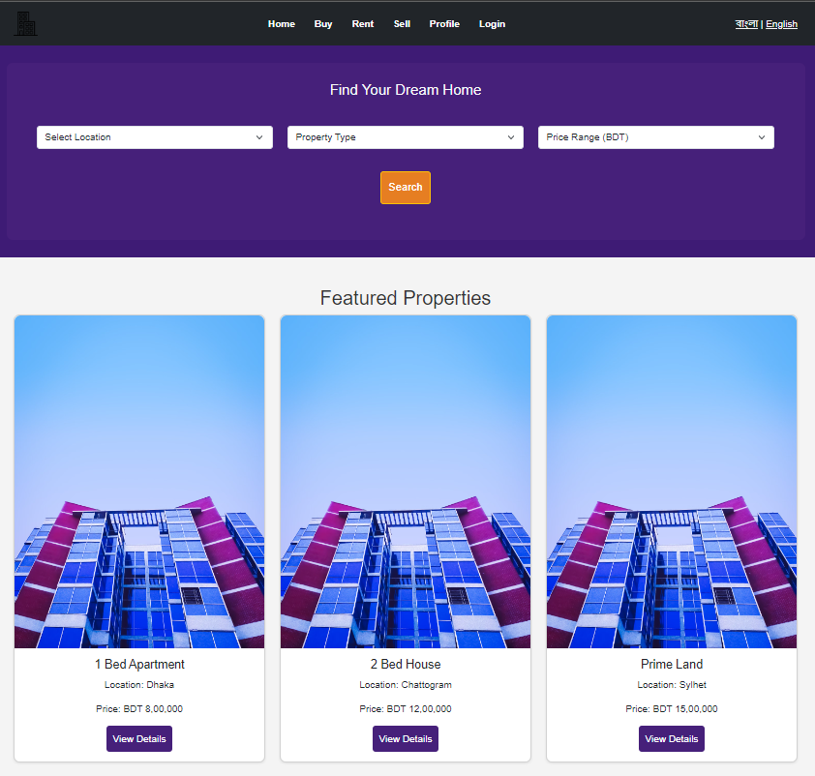
Log in and signup page -
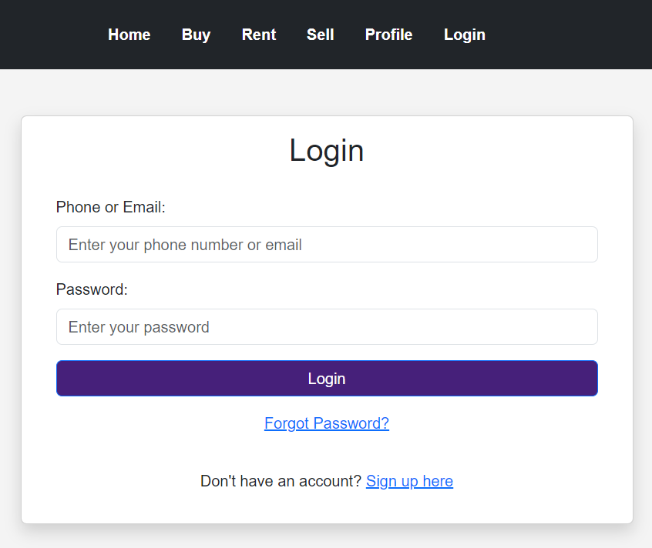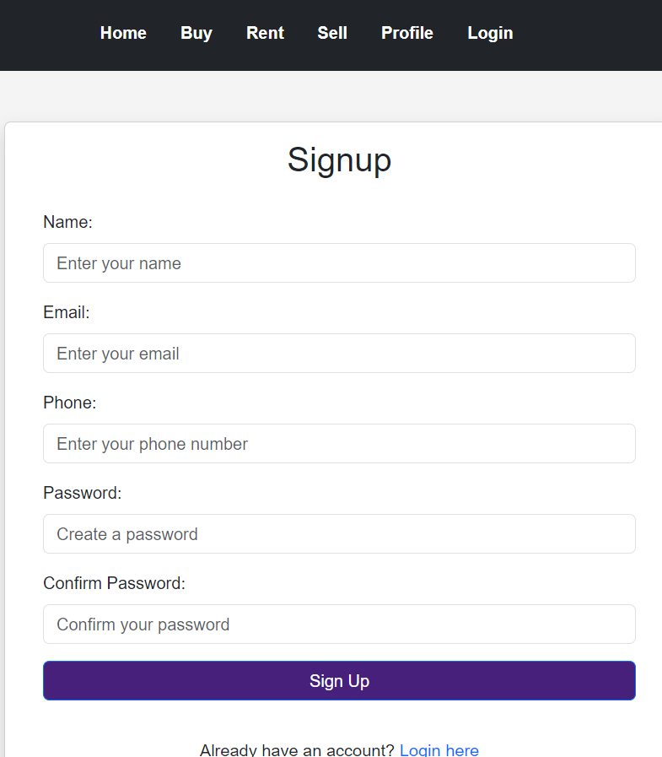
Rent/buy page -
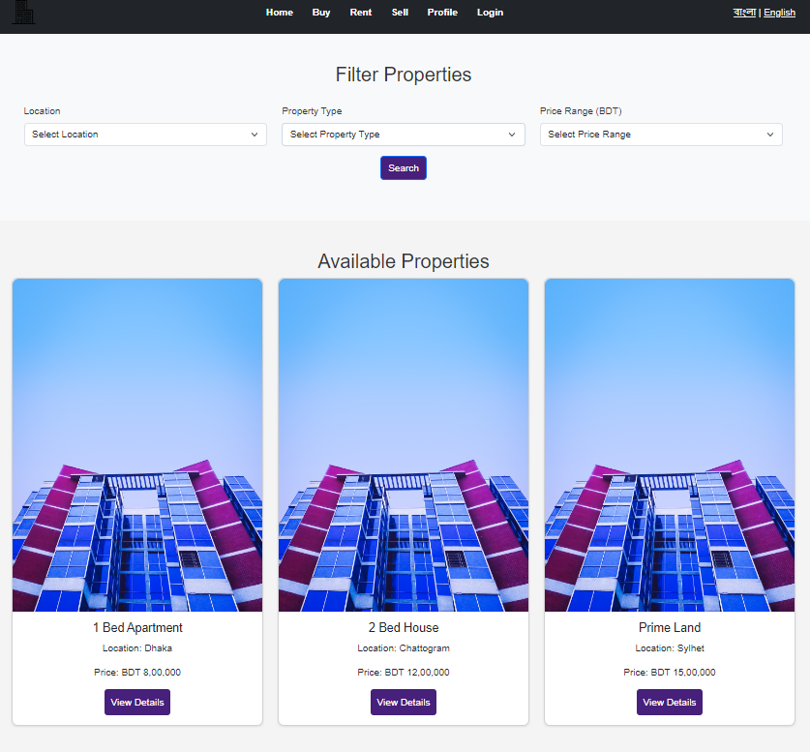
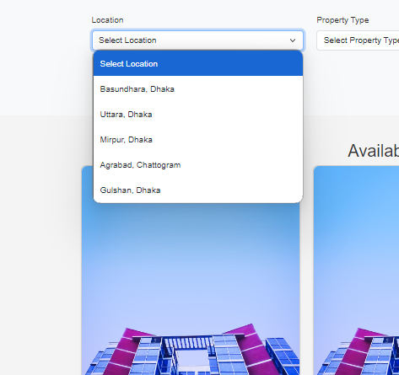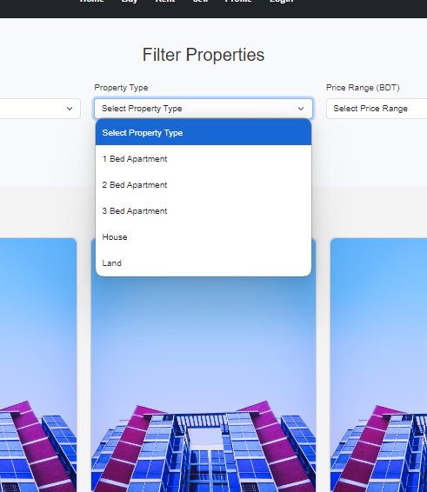
Submit listing
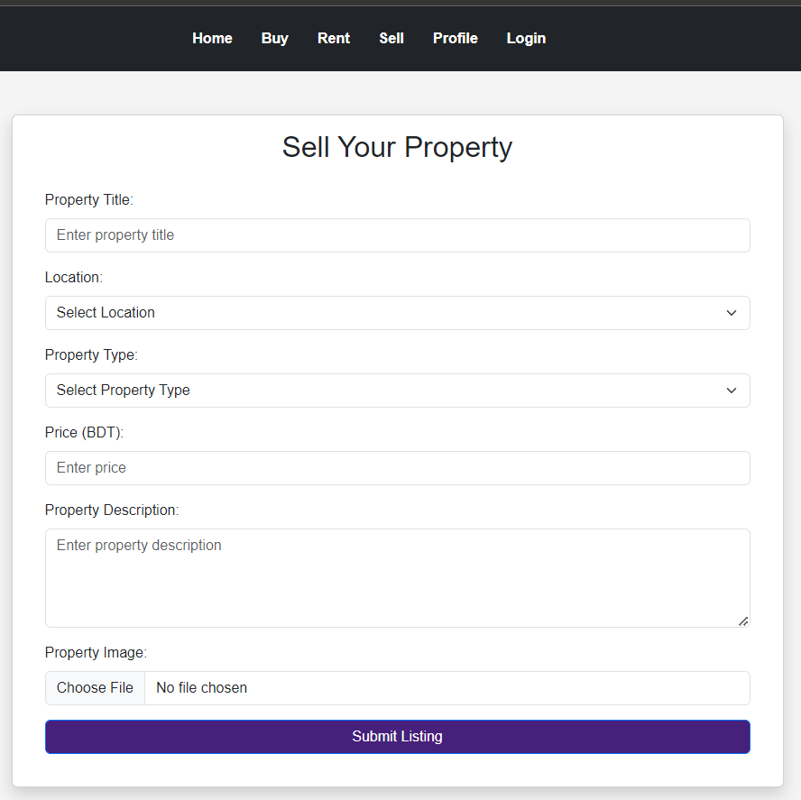
Chat interface -
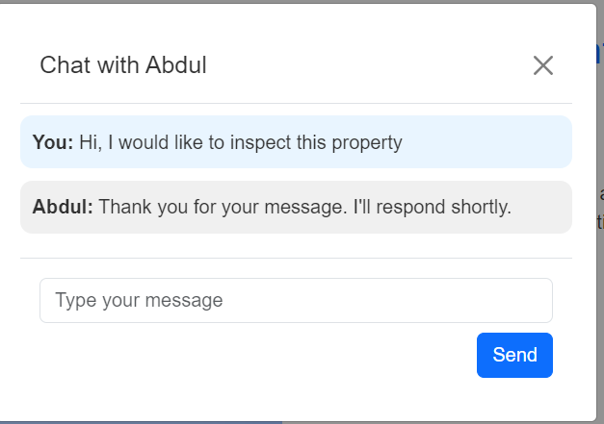

Research and investigations(Aaradhiya/Ruffin/Siam)
[In this part of the report, outline and detail the research that has been undertaken during the requirements analysis and system design stage. Theses research efforts may be related to understanding the system’s business/application domain, system design (eg, similar existing systems, architecture styles and patterns, etc), technological platforms and programming languages, sensors and so on.]
The architectural design and technology stack for this real estate platform were meticulously selected based on rigorous performance benchmarks and scalability requirements. The core technologies—Amazon Web Services (AWS) for cloud infrastructure, ReactJS for frontend development, MySQL for data persistence, and Node.js for backend services—were chosen after comparative analysis against alternatives. AWS provides a robust, scalable cloud environment, ReactJS offers a component-based architecture for efficient UI development, MySQL ensures ACID-compliant data storage, and Node.js enables high-performance, event-driven server-side operations.
During the requirements analysis and system design phases, extensive research was conducted into the technical landscape of the Bangladeshi real estate market. This investigation revealed critical gaps in existing platforms like Tolet and BD Housing, particularly in areas of real-time data synchronization, geospatial integration, and user authentication protocols. To address these deficiencies, the research focused on implementing WebSocket technology for real-time property updates, integrating the Google Maps API for interactive geospatial features, and designing a multi-factor authentication system to enhance platform security and user trust.
Architectural considerations led to the adoption of a monolithic design, leveraging AWS services such as Amplify for streamlined frontend deployment, Amazon RDS for managed MySQL instances, and S3 for scalable object storage. This architecture facilitates easier initial deployment and management while allowing for future microservices migration if required. The research also explored implementing a Cache-Aside pattern using Amazon ElastiCache to reduce database load and improve response times for frequently accessed data.
Security research was paramount, focusing on compliance with the Digital Security Act of Bangladesh and international data protection standards. The implementation plan includes AES-256 encryption for data at rest and TLS 1.3 protocols for data in transit. AWS Identity and Access Management (IAM) will be utilized to implement the principle of least privilege, while Security Groups will provide network-level isolation. Additionally, the research proposed implementing JSON Web Tokens (JWTs) for stateless authentication, supplemented by OAuth 2.0 for third-party integrations.
User experience (UX) and user interface (UI) research emphasized the importance of responsive design and progressive enhancement techniques to ensure optimal performance across various devices, particularly mobile platforms which dominate the local market. The frontend architecture will utilize React's Context API for state management, with Redux considered for more complex state scenarios. Internationalization will be implemented using the i18next library, allowing seamless switching between English and Bangla interfaces. The research also explored implementing a custom Bangla input method editor (IME) to facilitate easier text entry on various devices.
Geospatial functionality emerged as a critical feature, with research focusing on efficient integration of the Google Maps JavaScript API. Plans include implementing custom overlays using SVG and the Maps API's drawing tools to represent property boundaries. On the backend, the research proposed using MySQL's spatial extensions for geospatial indexing and querying, enabling efficient proximity-based searches.
Performance optimization strategies were extensively researched, including the implementation of a content delivery network (CDN) using Amazon CloudFront to reduce latency. The research also explored implementing server-side rendering (SSR) with Next.js to improve initial page load times and search engine optimization (SEO). Lazy loading techniques for images and below-the-fold content were identified as crucial for improving perceived performance, especially on slower mobile networks prevalent in the target market.
This comprehensive technical research lays the groundwork for developing a robust, scalable, and secure real estate platform tailored to the unique requirements of the Bangladeshi market. The proposed architecture and technology choices aim to address current market gaps while providing a flexible foundation for future enhancements and scalability.

research into the application domain(Ankit)
Overview of Existing Real Estate Apps and Websites in Bangladesh

Several platforms in Bangladesh cater to real estate needs, offering property
listings and rentals. The most relevant platforms include:
BProperty
Tolet
BDHousing

Each of these platforms provides users with a variety of property options, but they vary significantly in user experience, feature set, and performance. By understanding their limitations, we can design our app to offer a better, more focused experience, particularly for students.

Analysis of Existing Platforms

BProperty
Strengths:
Established platform with a large database of properties across major cities.
Provides detailed property listings with images, descriptions, and prices.
Allows users to schedule site visits directly through the platform.
Weaknesses:
Does not allow users to sell properties, limiting functionality.
The user interface is cluttered and not particularly student-friendly, which makes it harder for specific demographics to find affordable accommodations.
May experience performance issues during high-traffic periods, as there are no clear backend optimizations.

Tolet
Strengths:
Focuses on rentals, especially in urban areas, which is highly relevant to students seeking accommodation.
Simple interface for quickly listing rental properties.

Weaknesses:
Limited property listings in high-demand areas like Dhaka and Chittagong.
Lacks features like proximity-based search or advanced filtering for different user needs.
No built-in secure communication channels.
Performance under heavy load may suffer as there are no evident optimizations for handling high traffic.

BDHousing
Strengths:
Provides listings for residential, commercial, and rental properties.
Features detailed descriptions of properties.

Weaknesses:
Limited number of properties, particularly in non-urban areas.
The platform’s design is outdated, making it less appealing for mobile-first users, especially students.
No evident infrastructure to manage traffic surges, which could lead to slowdowns during peak periods.

Gaps and Opportunities

Several key gaps can be addressed:
- Student-Centric Listings: None of these platforms have a dedicated section for student accommodations, which are often mixed with more expensive listings. Our platform will isolate student listings, making it easy for them to find affordable housing.

- Performance Issues Under High Traffic: Given Bangladesh’s large real estate market and seasonal traffic spikes (especially during academic seasons), these platforms may experience performance issues without proper traffic management tools like load balancing and congestion control.

- Proximity-Based Search: Current platforms do not allow users to search based on proximity to key locations like universities and schools. Integrating Google Maps for proximity-based search is crucial for students seeking accommodations near educational institutions.

- Secure Communication Channels: Most platforms lack encrypted communication, which is critical for secure negotiations between buyers, sellers, and renters.

Proposed Solutions with AWS Services

- Our platform will address these gaps by providing student-centric listings, proximity-based search, and optimizations for high traffic. We will use AWS services to ensure the platform is scalable, secure, and responsive. Some AWS services may incur costs beyond the Free Tier, so those will be marked as out of scope for now but discussed for future use.

- Student-Centric Listings with Affordability Filters: The platform will have a dedicated section for student-targeted listings, ensuring they do not get lost among high-end properties. Affordability filters and proximity-based searches will help students quickly find accommodations near their institutions.

- Proximity-Based Search via Google Maps: Google Maps will be integrated to allow users to search based on proximity to schools, universities, hospitals, and transport hubs. This will particularly benefit students and make the search process smoother.

Optimized Performance with AWS Load Balancing:
Using AWS Elastic Load Balancer (ELB), we will distribute incoming traffic across multiple EC2 instances to prevent server overload. ELB, while not part of the Free Tier, offers a scalable solution for managing traffic surges. For now, it is out of scope but remains a viable solution as the platform grows.
Auto Scaling, which is available in the Free Tier, will dynamically add or remove EC2 instances based on traffic. This ensures we can handle surges in demand without manual intervention.

AWS-Managed Congestion Control:
AWS Global Accelerator, while out of scope, is an excellent tool for improving response times by routing user traffic to the nearest available server region. This service helps minimize latency across a large user base.
For real-time data transmission, AWS supports TCP congestion control algorithms like Cubic or Reno to manage how data packets are delivered during traffic spikes. Using these with AWS CloudFront can improve the speed of data transfer during peak usage, which is especially important for our student-heavy user base.

Rate Limiting with AWS API Gateway:
AWS API Gateway, which is part of the Free Tier, will help us manage and throttle API requests to ensure no single user overloads the system. This ensures the app remains responsive, even under heavy load.

Secure, Encrypted Communication:
We will use AWS Key Management Service (KMS), available under the Free Tier, for managing encryption keys securely. Alongside CryptoJS, we will implement real-time encrypted chat, ensuring secure communication between students and landlords, as well as other users.
AWS Secrets Manager will be considered for production use but is out of scope due to potential costs.

Mobile-First Design with AWS Amplify:
AWS Amplify, which is part of the Free Tier, will be used to build and deploy a mobile-first app. This ensures students, who primarily use mobile devices, have a seamless experience. Amplify integrates well with other AWS services like Cognito for authentication, providing a smooth development workflow.

Conclusion

Our platform will not only cater to the specific needs of students but will also address broader real estate needs, providing a secure, scalable, and high-performing platform. By using AWS Elastic Load Balancer (out of scope for now) and Auto Scaling (within scope), we can ensure that the platform performs well under heavy traffic, particularly during student-heavy seasons.

Additionally, AWS Global Accelerator (out of scope) and congestion control algorithms will manage network traffic, ensuring smooth data delivery. Rate limiting with API Gateway will prevent the system from being overwhelmed, while CryptoJS and KMS will ensure that user communications are secure and private.

All of these services are built with AWS, leveraging the Free Tier for development and testing, while more advanced services (though out of scope for now) are available for future scalability. This will allow us to offer a platform that not only meets the needs of students but also outperforms existing alternatives in terms of performance and user experience.

3.2 Research into system DESIGN (PRABESH)
[Present your research into the system design.]
While designing a system architecture for a real estate website that will be in practice in Bangladesh a developing country several key factors are considered such as availability, scalability, security, performance and cost-effectiveness. The traditional way of hosting web applications requires high upfront and maintenance costs, so we orchestrated system design in AWS cloud platform which is pay-as-you-go model and even some services are free to use. Below is a deeper exploration of how AWS services can leverage to build an optimized, scalable and secure system to host a real estate website targeted for Bangladesh.
Key considerations for the AWS architecture:
- Availability:
AWS cloud services are made to be highly available in different geographical regions and compatible with network needs. Moreover, cloud service is available from any location and at any time can significantly enhance the operational availability of organizations and industries in Bangladesh (Islam et al., 2017). As of 2024 AWS has 108 availability zone (AWS 2024) including 2 zones in Indian which is near to Bangladesh.

- Scalability & Traffic Handling:
The designed AWS System is highly scalable, the AWS amplify can cope with the growth of the traffic and automate scale to provide service without interruption user experience. Furthermore, AWS Amplify is a fully managed service that provides backend and frontend development capabilities without the need to manage servers like EC2. It has built in typescript, sever framework for developing application which is best suited for the developer.

- Cost Efficiency:
Developing countries often demand cost-effective solutions to be competitive. Building up physical servers requires huge upfront, and maintenance cost, using AWS cloud infrastructure the maintenance responsibility does not fall into the us which saves labour costs and huge amount of time. AWS offers a pay-as-you-go pricing model, enabling businesses to only pay for the resources that has been used, which is ideal for startup like ours or small to medium-sized enterprise (SMEs) with tight budgets.

- Latency and User Experience:
Considering Bangladesh's network infrastructure, minimizing latency is critical. AWS’s edge services like CloudFront will help reduce latency by delivering cached content from the nearest edge locations, improving the user experience across varying internet speeds. Since, the AWS has high geographical area coverage, users will get the service with low latency through good internet connectivity.

- Security and Compliance:
Given the increasing cybersecurity threats, protecting sensitive user data (e.g., personal information and transaction records) is critical. The Amazon Cognition enhance the authentication process of the user sing in and sing up. Moreover, utilizing AWS services like VPC, AWS WAF, and security groups will ensure that security is handled effectively, reducing the risk of breaches.

- Adaptability
As on my research there are many companies including banks who have already migrated to cloud environments. “Companies like ACI, Robi, Eastern Bank etc. are few of the so numerous mammoth companies who have considered having cloud administrations in their company” (Yusuf, Hasan, Adan and Mohamoud 2022). Since, the AWS cloud infrastructure has flexibility the project would benefit for the deployment in Bangladesh.

3.3 research into technical platform(SHIvam)

[Present your research into the technical platform.]

The technical platform for the real estate application targeting the Bangladeshi market is designed to deliver a secure, scalable, and localized solution that supports real-time updates, trust-building, and affordability. The selected tools and services focus on addressing the specific needs of the platform’s users: real estate professionals, buyers, sellers, and students looking for properties.
1. Frontend Technologies
The frontend of the platform needs to provide a smooth user experience, support localization, and handle real-time interactions effectively.
- 1.1 Web Frontend: React.js
Reasoning: React.js is chosen for its ability to create fast, responsive, and dynamic web interfaces. It easily integrates with third-party services like Google Maps API to offer an interactive property search. Additionally, localization (English and Bengali) is supported using libraries like react-i18next, making the platform accessible to a wide audience.
Key Feature: Fast real-time updates for property listings and support for multi-language functionality.

- 1.2 Mobile Frontend: React Native
Reasoning: React Native allows the platform to be deployed on both Android and iOS, which is critical for Bangladesh, where mobile devices are the primary access point to the internet. A mobile-first design ensures that users can search, view, and interact with listings from anywhere.
Key Feature: Cross-platform development ensures efficient and fast mobile app delivery, targeting Bangladesh’s mobile-centric users.
2. Backend Technologies
The backend handles user interactions, property listings, and verification processes in real-time while ensuring scalability and security.
- 2.1 Backend Framework: Node.js with Express.js
Reasoning: Node.js is ideal for handling real-time data and high traffic loads with its non-blocking architecture. It supports real-time chat and property updates through WebSockets, ensuring seamless communication between users and agents. Express.js provides a simple framework for managing API requests, making it easier to scale as user demand grows.
Key Feature: Real-time communication for users and agents, ensuring quick interaction and property status updates.
3. Cloud Infrastructure: Amazon Web Services (AWS)
AWS offers a reliable and scalable infrastructure to support the platform, particularly important for handling high traffic and ensuring security.
- 3.1 AWS Amplify
Reasoning: AWS Amplify simplifies integration with backend services and supports fast, scalable deployment. It also provides real-time capabilities, ensuring users get instant notifications about property updates or responses from agents.
Key Feature: Seamless integration for real-time property updates and notifications.

- 3.2 Amazon RDS (Relational Database Service)
Reasoning: RDS provides a managed relational database for storing structured data like property listings, user profiles, and transactions. It supports automatic backups and can scale as the platform grows.
Key Feature: Reliable and scalable database management with automated backups.

- 3.3 Amazon S3 (Simple Storage Service)
Reasoning: Amazon S3 stores property images and videos securely and at scale, ensuring that users can easily view rich media content without impacting performance.
Key Feature: Scalable and cost-effective media storage for property listings.

- 3.4 Amazon CloudFront (CDN)
Reasoning: CloudFront reduces the loading time for users by caching property images and videos across multiple regions, improving performance for users across Bangladesh.
Key Feature: Faster content delivery through global edge locations, improving user experience in remote areas.
4. Security Features
Given the need to build trust in the platform, security is a priority.
- 4.1 AWS WAF (Web Application Firewall)
Reasoning: AWS WAF protects the platform from common threats like SQL injection and DDoS attacks, which are crucial to maintaining trust in real estate transactions.
Key Feature: Ensures protection against common vulnerabilities, keeping user data secure.
5. Third-Party API Integrations
The platform integrates third-party APIs to provide location-based search and real-time communication.
- 5.1 Google Maps API
Reasoning: Google Maps enables location-based property searches, allowing users to find properties near landmarks such as schools and universities, particularly useful for students.
Key Feature: Interactive map-based search, helping users visualize properties in relation to their surroundings.

- 5.2 Firebase Cloud Messaging (FCM)
Reasoning: FCM supports real-time push notifications, alerting users to new listings or updates to favorite properties.
Key Feature: Real-time notifications for property updates and agent responses, enhancing user engagement.

3.4 other research ( Everyone)
[Present any other related research.]

Kost analysis (Everyone)
[Present a mapping of knowledge, skill and technology requirements of the selected architecture design to what you have in the team. Clearly indicate any gap that may exist and a plan to overcome that.]
The development of the real estate platform for the Bangladeshi market requires a detailed evaluation of the team’s Knowledge, Skills, and Technology (KOST). This analysis ensures that the selected architecture aligns with the team’s capabilities while identifying gaps and formulating strategies to overcome them.
Knowledge
The team possesses a strong foundational knowledge of web and mobile application development. This includes understanding the real estate domain through research into platforms like Tolet and BD Housing. However, the team has limited experience with the specific needs of the Bangladeshi real estate market, such as the cultural nuances in property transactions and the trust challenges posed by unverified listings. To address this gap, the team has consulted with stakeholders familiar with the local market and conducted extensive research into user behavior in Bangladesh (Rahman & Sarker 2023). Additionally, the team plans to gather user feedback through surveys and focus groups to further understand the local market requirements.
Skills
The team has solid skills in backend development, particularly in using Node.js and React.js for handling server-side tasks, and React.js for frontend development. They also have experience in database management using MySQL, making them well-suited to implement the platform’s core functionalities like user authentication, property listings, and secure messaging. However, there is a skill gap in advanced cloud architecture, particularly in using AWS services like Lambda for serverless computing and S3 for media storage. To address this, the team will undertake targeted AWS training using online resources and official documentation. Additionally, there is a minor skill gap in integrating third-party APIs such as Google Maps for the interactive property search, which the team plans to fill by utilizing open-source libraries and tutorials (AWS 2024).
Technology
The chosen technology stack includes React.js for frontend development, Node.js and Express.js for the backend, AWS for cloud infrastructure (Amplify, RDS, Lambda, and S3), and Google Maps API for location-based services. This technology stack is aligned with the team's skill set, with React.js and Node.js being familiar tools that the team has used in previous projects. AWS was selected for its scalability and cost-effectiveness, especially under the free tier for early-stage development. The main technology gap lies in managing serverless architecture (AWS Lambda) and efficient media storage (S3). To bridge this gap, the team plans to leverage AWS’s extensive documentation and support forums to gain proficiency in these areas.
Gap Plan
While the team has adequate knowledge and skills in most areas, the primary gaps are in AWS cloud services, particularly Lambda and S3, and advanced Google Maps integration. To address this, the team will enroll in AWS training courses and consult the AWS Solutions Architect guides for best practices. Additionally, the team will allocate time for prototyping and testing third-party API integrations, ensuring seamless map-based property search features. With these measures in place, the team is confident in overcoming the skill and technology gaps and delivering a robust, scalable platform.

reference (if any)
[If you have used information from published sources, show where it came from here (and cite them in the relevant places of this report). Use the Harvard system of citation (or another system, but be consistent). For instance, they may be books, journal articles, or websites.]
AWS 2024, Cloud Computing Services, Amazon Web Services, viewed 22 September 2024, https://aws.amazon.com/.
Rahman, A & Sarker, M 2023, Emerging Trends in Real Estate Technology in Bangladesh, Bangladesh Journal of Economic Studies, vol. 12, no. 1, pp. 77-89.
Khaled, M. C., Sultana, T., Biswas, S. K., & Karan, R. (2012). Real estate industry in Chittagong (Bangladesh): A survey on customer perception and expectation. Developing Country Studies, Vol. 2(No. 2), 38-45. Retrieved from http://www.iiste.org
Barua, S., Mridha, A. H. A. M., & Khan, R. H. (2010). Housing real estate sector in Bangladesh: Present status and policy implications. ASA University Review, Vol. 4(No. 1), 2010.
AWS, Building a Containerized and Scalable Web Application on AWS, Amazon Web Services, 2024, viewed 22 September 2024, https://aws.amazon.com/solutions/guidance/building-a-containerized-and-scalable-web-application-on-aws/.
AWS, An AWS Cloud Architecture for Web Hosting, Amazon Web Services, 2024, viewed 22 September 2024, https://docs.aws.amazon.com/whitepapers/latest/web-application-hosting-best-practices/an-aws-cloud-architecture-for-web-hosting.html.
AWS, AWS WAF, Amazon Web Services, 2024, viewed 22 September 2024, https://aws.amazon.com/waf/.
AWS, Amazon CloudFront, Amazon Web Services, 2024, viewed 22 September 2024, https://aws.amazon.com/cloudfront/.
AWS, Amazon Route 53, Amazon Web Services, 2024, viewed 22 September 2024, https://aws.amazon.com/route53/.
AWS, AWS Global Infrastructure, Amazon Web Services, 2024, viewed 23 September 2024, https://aws.amazon.com/about-aws/global-infrastructure/.
AWS, Amazon RDS, Amazon Web Services, 2024, viewed 22 September 2024, https://aws.amazon.com/rds/?gclid=Cj0KCQjwgL-3BhDnARIsAL6KZ6-iLIj_h4WnILk_GJv6nlUlJwQNuHXMex4Efdjb9ktqzNmB3zNXpRsaAnt6EALw_wcB&trk=f8c749c2-a797-41e7-9b4d-743b10b206a3&sc_channel=ps&ef_id=Cj0KCQjwgL-3BhDnARIsAL6KZ6-iLIj_h4WnILk_GJv6nlUlJwQNuHXMex4Efdjb9ktqzNmB3zNXpRsaAnt6EALw_wcB:G:s&s_kwcid=AL!4422!3!549058196525!e!!g!!amazon%20rds!11539887576!114142396522.
Islam, M.A., Kasem, F.B.A., Khan, S., Habib, M.T. and Ahmed, F., 2017. Cloud computing in education: Potentials and challenges for Bangladesh. International Journal of Computer Science, Engineering and Applications, 7(5), pp.11-21
Yusuf, A.H., Adan, J., Hasan, F. and Mohamoud, H. (2022). Case study usage and challenges of AWS in Bangladesh and in Somalia. [online] pp.1–25. Available at: https://www.researchgate.net/publication/359352577_Case_study_usage_and_challenges_of_AWS_in_Bangladesh_and_in_Somalia [Accessed 23 Sep. 2024].

[Your reference list entry must be in the form of
Author, Initial(s), Title of Document/Webpage/Website/article, Organisation/Host/journal/conference, Year, viewed Day Month Year, <URL>.
example
T. Kanij, R. Merkel and J. Grundy, "Lessons learned from conducting industry surveys in software testing," 2013 1st International Workshop on Conducting Empirical Studies in Industry (CESI), San Francisco, CA, USA, 2013, pp. 63-66, doi: 10.1109/CESI.2013.6618474. ]
[Your in-text may be in the form of
- Direct quote
"Most software testing techniques ..." (Kanij 2013).
- Paraphrase
Kanij (2013) reviewed software tasters’ engagement in empirical research ...]
[For more information on the Harvard style guide
refer to
http://www.swinburne.edu.au/lib/studyhelp/harvard_style.html]

- Client Sign off

Name | Position | Signature | Date
Organization
[Client to sign off on the design Plan to signify they agree with the plan]

